The Art of Peace

Saturday 16th November
2:00-5:00

Wimbledon Library, Wimbledon Hill Road SW19 7NB

An exhibition of creative work by mainly local artists including Edwin Cluer (sample below).

Admission Free – Donations Welcome
Refreshments Available

Be stimulated by the exhibited ideas of peace and share/discuss your own

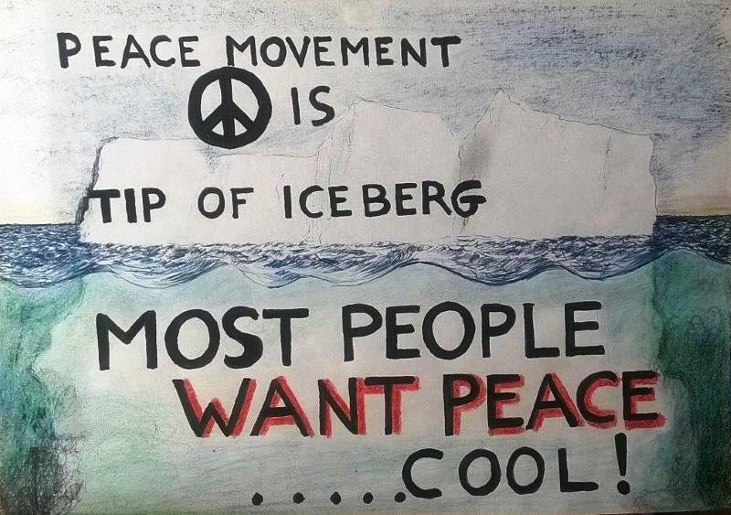

Sponsored by Wimbledon Disarmament Coalition/CND

